

Exploring Pythagoras’ theorem with TI-NspireTM NavigatorTM

Jay Timotheus – Blue Coat CE School, Walsall, England

Case Study
Exploring Pythagoras’ theorem with TI-NspireTM NavigatorTM

Teacher | Jay Timotheus
Location | Blue Coat Church of England School, Walsall, England
Class | Year 10 students studying for a GCSE Higher Examination Course
Technology | TI-NspireTM NavigatorTM

Setting
Blue Coat School is a state secondary school for students aged 11-18 years in Walsall, UK. Some of the students in this class have been using the TI-NspireTM handhelds since 2008 and I have been using TI-NspireTM NavigatorTM with these students since May 2009. In this lesson I used File transfer, Screen Capture, Live Presenter and File collection.

The lesson
I transferred a pre-constructed file that I had created to the students’ handhelds. I then used Live Presenter to help the students locate and open the file and remind them how to select and drag objects. The initial task showed three connected dynamic squares which I asked the students to manipulate to try to make them all have the same area measurements. I used this task to make sure that they were all able to grab and drag objects using the TI-NspireTM handhelds and share some of their mathematical strategies.
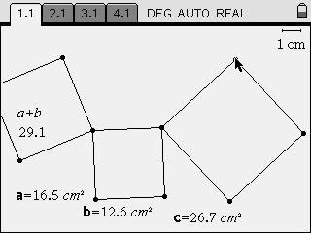

In the second task, the three squares had been joined together and, this time I asked the students to try to make the areas of the two squares, with area measurements labelled a and b, sum to give the area measurement c.
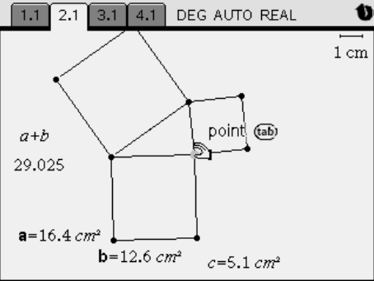

When all the students had attempted the task, I displayed the Screen Capture view and we discussed the similarities and difference between the different screens. We were able to conclude that, when the areas labelled a and b summed to equal area c, the triangles appeared to be right angled triangles. This class conclusion was helped by one student who did not follow the instructions, but got the areas b and c to equal the area a. She too had achieved a right-angled triangle and this example helped illustrate the generality in the task.

Students’ mathematical learning
All of the students were able to see very quickly that, when the condition for the areas being equal was true, the triangles appeared to be right angled and, having recorded this ‘rule’ in their own words, I felt that we were in a good position to try to apply this to a new problem in a subsequent lesson when we would look at more traditional problems involving Pythagoras’ theorem.

Conclusion
The students seemed more motivated to engage in the mathematics because we had made the conjecture about the relationship between the areas of the squares as a class, and all of their screens had contributed to this conclusion. They also seemed to be interested in how other students had approached the different problems.

